Ex.No:1: Simulation of FDMA in MATLAB
Date
Aim: To simulate a Frequency Division Multiple Access (FDMA) system using MATLAB
and analyze its communication performance in terms of channel bandwidth, data rate, and
signal-to-noise ratio (SNR).
Objective 1:
To simulate an FDMA system by allocating individual frequency channels to multiple users
and determine the channel bandwidth assigned to each user.
Output Parameter: Channel Bandwidth (kHz)
Objective 2:
To calculate the data rate achieved by each user in the FDMA system based on the allocated
channel bandwidth.
Output Parameter: Data Rate (kbps)
Objective 3:
To evaluate the communication quality of the FDMA system by calculating the Signal-to
Noise Ratio (SNR) for different users.
Output Parameter: Signal-to-Noise Ratio (SNR) (dB)
Procedure
1. Open MATLAB and create a new script file.
2. Define the total available bandwidth, number of FDMA users, carrier frequencies, signal
power, and noise power.
3. Allocate a unique frequency channel to each user and calculate the channel bandwidth.
4. Compute the data rate for each user based on the allocated bandwidth and modulation
scheme.
5. Calculate the Signal-to-Noise Ratio (SNR) using the signal and noise power values.
6. Plot the transmitted signals of all FDMA users using different carrier frequencies.
7. Display the calculated channel bandwidth, data rate, and SNR in the MATLAB
Command Window.
8. Analyze the results to verify independent channel allocation and evaluate the overall
performance of the FDMA system.
Program (Matlab Code)
clc; clear; close all;
fs=1000; t=0:1/fs:1;
TBW=600; Users=3;
CBW=TBW/Users;
fc=[100 300 500];
m=sin(2*pi*10*t);
s1=m.*cos(2*pi*fc(1)*t);
s2=m.*cos(2*pi*fc(2)*t);
s3=m.*cos(2*pi*fc(3)*t);
subplot(2,1,1)
plot(t,s1,'r',t,s2,'g',t,s3,'b'),grid on
title('FDMA Channel Allocation'),xlabel('Time (s)'),ylabel('Amplitude')
subplot(2,1,2)
bar(1:Users,CBW*ones(1,Users)),grid on
xlabel('Users'),ylabel('Channel Bandwidth (kHz)'),title('Channel Bandwidth per User')

Output:
Objective 1:
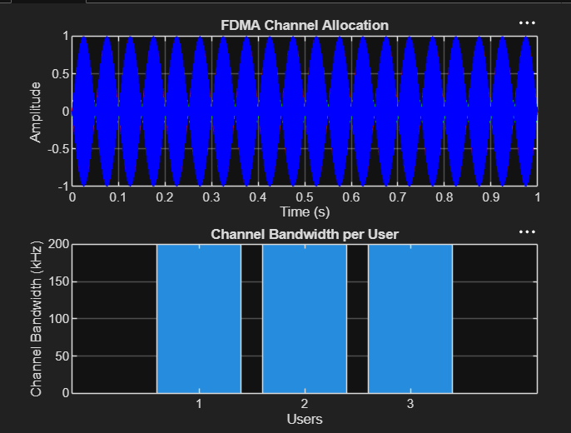

Objective 2: Matlab Code and Ootput
clc; clear; close all;
BW = 200;
Users = 3;
M = 2;
% Channel Bandwidth (kHz)
% BPSK Modulation
DataRate = BW*log2(M);
% Data Rate (kbps)
Rate = DataRate*ones(1,Users);
disp(' User Data Rate (kbps)')
disp([(1:Users)' Rate'])
figure
bar(1:Users,Rate)
xlabel('Users')
ylabel('Data Rate (kbps)')
title('FDMA Data Rate for Each User')
grid on
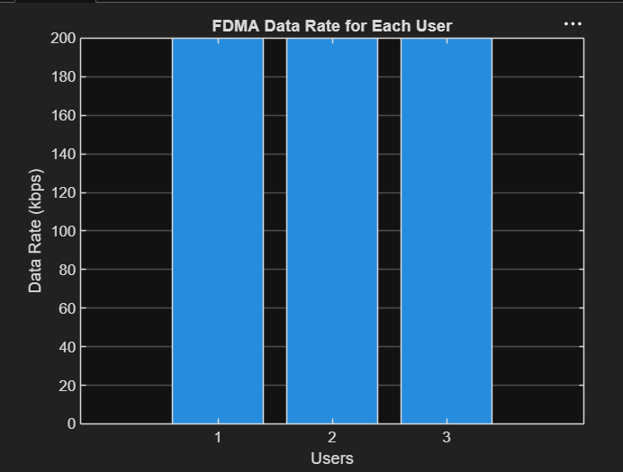

Objective 3: Matlab Code and Ootput
clc; clear; close all;
Ps = 1;
Pn = [0.1 0.05 0.01];
% Signal Power (W)
% Noise Power (W)
Users = 1:3;
SNR = 10*log10(Ps./Pn);
% SNR in dB
disp('User Noise Power(W) SNR(dB)')
disp([Users' Pn' SNR'])
figure
bar(Users,SNR)
xlabel('Users')
ylabel('SNR (dB)')
title('Signal-to-Noise Ratio of FDMA Users')
grid on

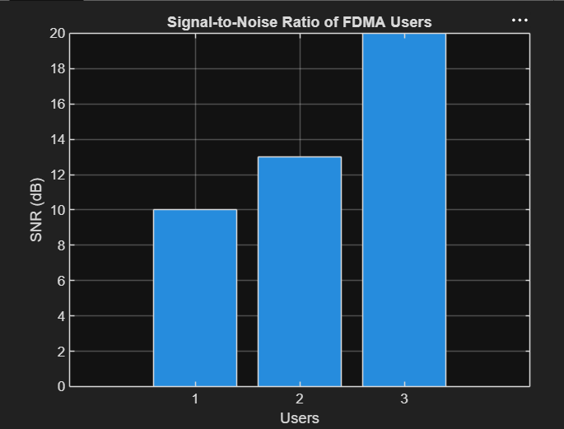

Result:
1. The FDMA system was successfully simulated by allocating separate frequency channels
to three users, and the channel bandwidth assigned to each user was determined.
2. The data rate achieved by each user was successfully calculated based on the allocated
channel bandwidth, demonstrating equal transmission capacity for all users.
3. The Signal-to-Noise Ratio (SNR) for different users was successfully evaluated,
showing that higher SNR values provide better communication quality and reliable data
transmission.

